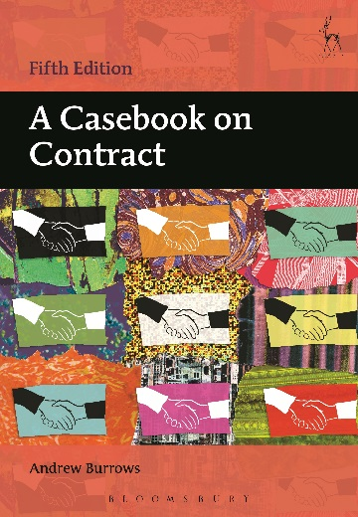
FIFTH EDITION
A Casebook on Contract
Andrew Burrows
Edited by

This is the fifth, fully updated, edition of Professor Burrows' casebook, offering law students the ideal way to discover and understand contract law through reading highlights from the leading cases. Designed to be used either on its own or to supplement a contract law textbook, this book covers the undergraduate contract law course in a series of clearly presented and carefully structured chapters. The author provides an expert introduction to each topic and his succinct notes and questions seek to guide students to a proper understanding of the cases. The relevant statutes are also set out along with a principled analysis of them. In addition to cross-references to further discussion in the leading textbooks, an innovative feature is the summary of leading academic articles in each chapter. The book is designed not to overwhelm students by its length but covers all aspects of the law of contract most commonly found in the undergraduate curriculum.

Andrew Burrows, MA, DCL, LLM (Harvard), QC (Hon), FBA, Barrister and Honorary Bencher of Middle Temple is Professor of the Law of England in the University of Oxford and a Fellow of All Souls College. He has been a Law Commissioner for England and Wales,

September 2016 | 9781509907700 | 936pp | Paperback | RSP: £32.99
Discount Price: £26.39

